CRICKSTATS
Cricket Player Performance Tracking System Naan Mudhalvan Project Documentation
Project Title : CRICKSTATS – Cricket Player Performance Tracking System
Submitted By,
Team Members Name : Arthi.R, Dharshini.V , Niranjana.P, Dharshini.R
Department : III-BCA.,
Institution Name : Krishnasamy College of Science Arts And Management for Women
Submitted To,
Naan Mudhalvan Program Academic Year : 2026 – 2027
Declaration

I hereby declare that the project titled “CRICKSTATS –
Cricket Player Performance Tracking System” submitted as part of the Naan Mudhalvan program is a record of the work carried out by me. The Information and data included in this project documentation are prepared based on my knowledge and learning during the project development process. I confirm that this work has not been submitted for any other academic purpose.
Acknowledgement

I would like to express my sincere gratitude to everyone who supported me in completing this project successfully. First, I thank my college management for providing the opportunity to participate in the Naan Mudhalvan program. I sincerely thank my faculty guide for providing valuable guidance and suggestions during the development of this project. I also thank the Naan Mudhalvan team for organizing this program and providing training resources. Finally, I thank the Salesforce platform which helped me develop and implement this project successfully
TABLE OF CONTENTS:

s.no | Topic
01 | INTRODUCTION
1.1 | Project Overview
1.2 | Purpose of the Project
1.3 | Scope of the Project
02 | IDEATION PHASE
2.1 | Problem Statement
2.2 | Empathy Map
2.3 | Brainstorming
03 | REQUIREMENTS ANALYSIS
3.1 | Functional Requirements
3.2 | Non-Functional Requirements
04 | SYSTEM DESIGN
4.1 | Data Flow Diagram
4.2 | Entity Relationship Diagram
05 | PROJECT PLANNING
5.1 | Development Methodology
5.2 | Sprint Planning
06 | PROJECT DEVELOPMENT
07 | TESTING
08 | RESULT
09 | ADVANTAGES
10 | LIMITATION
11 | CONCLUSION
12 | FUTURE SCOPE
13 | REFERENCES

CRICKSTATS – Cricket Player Performance
Tracking System
- INTRODUCTION
In modern sports management, data plays a crucial role in evaluating player performance and making strategic decisions. Cricket teams rely heavily on performance statistics such as batting averages, bowling figures, and fielding records to analyse player strengths and weaknesses.
CRICKSTATS is a cloud-based application developed using the Salesforce platform to manage and analyse cricket player performance efficiently. In traditional sports management systems, player statistics are often recorded manually in notebooks or spreadsheets. While this method may work for small datasets, it becomes inefficient when managing large volumes of match statistics.
Manual record keeping often results in problems such as data duplication, human errors, loss of records, and difficulty in analysing long-term performance trends. It also makes it challenging for coaches and analysts to quickly access player performance history during team selection or strategy planning.
To overcome these challenges, the CRICKSTATS system provides a centralized digital platform that allows cricket teams to store, manage, and analyse player performance data in an organized and secure manner. The system uses the powerful cloud capabilities of Salesforce to ensure that the data is easily accessible, secure, and scalable.
The application enables coaches, team managers, and analysts to track player statistics, generate reports, and visualize performance trends through interactive dashboards. This helps improve decision-making and enhances overall team performance.

Project Overview
CRICKSTATS is a Salesforce-based application designed to track and manage cricket players’ performance statistics in a systematic manner.
In many sports teams and academies, player performance information is traditionally recorded using notebooks, score sheets, or spreadsheet files. Although these methods are widely used, they often create challenges such as data inconsistency, calculation errors, and difficulty in retrieving historical records.
The CRICKSTATS system solves these problems by providing a centralized cloud-based platform where all player data and match statistics are stored in a structured database. This allows users to
easily manage, update, and analyse player performance information.
The system enables coaches, team managers, and sports analysts to record and monitor player performance metrics such as:
    - Runs scored
    - Balls faced
    - Wickets taken
    - Fours and sixes
    - Overs bowled
    - Catches and fielding statistics
    - Match details such as venue and opponent team
Using this system, users can generate automated reports and dashboards that provide insights into player performance trends across multiple matches and tournaments.
These insights help teams make informed decisions regarding player selection, training strategies, and match preparation.

Purpose of the Project
The primary purpose of this project is to develop a digital system that simplifies the management of cricket performance statistics.
The project aims to replace traditional manual record keeping with a structured and automated database system that improves
accuracy, accessibility, and efficiency.
By implementing the CRICKSTATS system on the Salesforce platform, teams can securely store and analyse large volumes of player performance data while reducing manual effort.
Objectives of the Project
The key objectives of the CRICKSTATS project include:
- Digitalizing player performance records
- Maintaining cricket statistics in a centralized cloud database
- Eliminating manual data entry errors
- Generating automated performance reports
- Supporting performance analysis through dashboards
- Improving decision-making for team selection and strategy
- Utilizing Salesforce automation features for efficient data processing
Through these objectives, the project aims to enhance the overall management of cricket statistics and improve the analytical capabilities of sports teams.

Scope of the Project
The CRICKSTATS application focuses on tracking player performance and managing cricket match statistics in a centralized system.
The system provides several important functionalities that allow users to efficiently manage cricket data.
These functionalities include:
    - Player registration and profile management
    - Match performance data entry
    - Automatic calculation of player statistics
    - Performance reporting and analysis
    - Dashboard visualization for easy interpretation of data
The system is designed primarily for use by coaches, team managers, and sports analysts who need reliable information about player performance.
Although the current version focuses mainly on performance tracking and reporting, the project has the potential to be extended in the future.
Future Scope
Possible future enhancements of the CRICKSTATS system include:
    - Mobile application integration for easy access
    - Advanced analytics using artificial intelligence
    - Real-time match score integration
    - Player performance prediction models
    - Integration with sports management systems
These improvements could further enhance the usefulness of the system for professional cricket teams and sports organizations.

IDEATION PHASE
The ideation phase is an important stage in the project development process where problems are identified and innovative solutions are explored.
During the initial discussions for this project, it was observed that many cricket teams and sports academies lack an efficient system for managing player performance statistics.
In most cases, match data is recorded manually using notebooks or spreadsheets. While these methods may be simple to implement, they become difficult to manage when the amount of data increases.
Manual systems create several challenges, such as:
- Difficulty in storing large volumes of performance data
- Errors in manual calculations of averages and statistics
- Lack of proper data analysis tools
- Difficulty in retrieving historical performance records
- Inefficient reporting processes
To address these issues, brainstorming sessions were conducted to identify potential technological solutions.
Several ideas were explored, including:
- Mobile applications for score tracking
- Web-based player management systems
- Cloud-based sports analytics platforms
- AI-powered performance prediction systems
After evaluating these ideas based on feasibility, scalability, and ease of implementation, the development team decided to build a Salesforce-based cricket performance tracking application.
Salesforce was chosen as the development platform because it offers several advantages, including:
- Secure cloud storage for large datasets
- Easy creation of custom objects and data models
- Automation tools such as workflows and flows
- Built-in report and dashboard generation features
- Role-based access control for different users Thus, the final concept of the project became:

CRICKSTATS – Cricket Player Performance Tracking System
This system provides a reliable and scalable solution for managing cricket performance data efficiently.

Problem Statement
Managing cricket statistics manually is a time-consuming and inefficient process.
Many sports teams maintain player statistics in multiple notebooks, spreadsheets, or separate files. This scattered approach makes it difficult to track player performance over time.
Manual data management also increases the chances of calculation errors, duplicate records, and data loss.

Empathy Map
An Empathy Map is a design thinking tool used to understand the users of a system. It helps developers analyse what users think, feel, say, and do while interacting with a product or service.
In the CRICKSTATS system, the primary users include coaches, team managers, players, and sports analysts. These users need a reliable system to track player statistics and analyse team performance.
Understanding user behaviour and expectations helps developers design a system that is easy to use and meets the real needs of its users.

User Persona
The main user persona considered for this system is a Cricket Team Coach or Team Manager.
These users are responsible for:
- Monitoring player performance
- Selecting players for matches
- Analysing team statistics
- Preparing performance reports
They require a system that is simple, accurate, and capable of storing large amounts of performance data.

What the User THINKS
Users often think about how to improve the performance of their players and team. They analyse past match statistics to identify strengths and weaknesses of players.
Some common questions they think about include:
- Which player is performing consistently well?
- Which player needs improvement in batting or bowling?
- How can statistics help in better team selection?
Users expect a system that provides quick access to accurate performance information so that they can make better decisions.

What the User FEELS
Users may feel stressed when they have to manage large amounts of match data manually. They can also feel frustrated when statistics are lost or difficult to find in notebooks or spreadsheets.
When using a reliable digital system like CRICKSTATS, users feel more confident because the data is organized, secure, and easily accessible.

What the User SAYS
Users often express their concerns about manual record keeping. Some common statements include:
- “Tracking player performance manually is difficult.”
- “We need a better system to store match statistics.”
- “It would be helpful to view player performance in charts and reports.”
These statements clearly show the need for a digital solution that simplifies performance tracking.

What the User DOES
Users normally perform several activities while managing cricket statistics, such as:
- Recording player performance after each match
- Analysing match statistics
- Comparing player performances
- Selecting players for upcoming matches
- Preparing reports for team management
In traditional systems, these tasks are done manually. The CRICKSTATS system automates these tasks, making the process faster and more efficient.

User PAINS (Problems)
Users face many challenges when managing performance data manually, including:
- Difficulty storing large amounts of data
- Errors in manual calculations
- Time-consuming data entry
- Difficulty analysing long-term player performance
- Lack of graphical reports and dashboards
- Risk of losing important records
These problems highlight the need for a centralized digital platform like CRICKSTATS.

User GAINS (Needs and Expectations)
Users expect a system that can simplify their work and help them make better decisions.
Some important expectations include:
- Easy player registration and data entry
- Accurate recording of match statistics
- Automated performance calculations
- Graphical reports and dashboards
- Quick access to historical performance data
- Secure storage of player information
The CRICKSTATS system is designed to meet these needs by providing a cloud-based platform for cricket performance management.

Brainstorming
Brainstorming is the process of generating ideas and identifying possible solutions for developing the CRICKSTATS system. It helps the development team explore different approaches to solve the problem of managing cricket statistics.

Problem Identification
Several problems were identified during the brainstorming stage:
- Cricket teams record player performance manually.
- Manual records can lead to calculation errors and data loss.
- Tracking player performance across multiple matches is difficult.
- Comparing player statistics takes a lot of time.

Idea Generation
Different ideas were discussed to solve these problems, such as:
- Developing a digital system to store cricket statistics
- Creating dashboards to track player performance
- Automating batting and bowling calculations
- Providing easy performance analysis for coaches

Feature Ideas
The following features were suggested during brainstorming:
- Player profile management
- Match data entry system
- Automatic performance calculation
- Graphical reports and statistics
- Player comparison feature
- Search and filter options

Technology Consideration
To build the CRICKSTATS system, the following technologies were considered:
- Frontend: HTML, CSS, JavaScript
- Backend: Python or Java
- Database: MySQL or MongoDB
These technologies help create a reliable and efficient performance tracking system.

Expected Outcome
The expected outcomes of the system include:
- Easy tracking of cricket player performance
- Accurate statistical analysis
- Quick report generation
- Better decision-making for coaches and teams

Final Idea Selection
During the brainstorming stage, several project ideas were discussed, such as:
- Cricket statistics website
- Mobile cricket analytics application
- AI-based performance prediction system
- CRM-based performance tracking system

Some of the major problems associated with manual systems include:
- Data duplication across multiple files
- Human errors during manual calculations
- Slow report generation
- Difficulty in performing long-term performance analysis
- Lack of visual data representation
These limitations highlight the need for a centralized digital system that can store, manage, and analyse cricket player statistics in a structured and reliable way.

Requirement Analysis
Requirement analysis is the process of identifying and understanding the needs of users and defining the features that the system must provide. It helps in determining what the system should do and how it should perform.
For the CRICKSTATS system, requirement analysis focuses on creating a platform that allows coaches, players, and administrators to manage and analyse cricket performance data efficiently.
The system includes the following requirements:
- Admin and user login system
- Secure authentication for coaches, players, and administrators
- Role-based access control (Admin, Coach, Player)
- Player information management
- Performance analysis and player comparison
- Prevention of unauthorized access to data
These requirements help ensure that the system operates securely and effectively.

Functional Requirements
Functional requirements describe the specific functions or operations that the system must perform. These requirements define how the system interacts with users and processes data.
The key functional requirements of the CRICKSTATS system are as follows:
Player Registration
The system should allow administrators or coaches to register new cricket players by entering details such as player name, age, role, team, and contact information.
Match Performance Recording
The system should allow users to record match statistics including runs scored, balls faced, wickets taken, overs bowled, and catches.
Performance Reports
The system should generate reports that display player performance across multiple matches. These reports help coaches analyse player progress.
Dashboard Visualization
The system should provide graphical dashboards that show player statistics, performance trends, and comparisons.
Data Storage
The system should securely store all player and match information in a cloud database to ensure easy access and data safety.
FR No Description
FR1 Add player details
FR2 Record match performance Generate performance
FR3
reports
FR4 Display dashboards
Implement automation
FR5
flows

Non- Functional Requirements
Non-functional requirements describe the quality and performance standards of the system. These requirements focus on how well the system works rather than what functions it performs.
Usability
The system should be simple and easy to use for coaches and administrators.
Features include:
- Simple user interface
- Clear navigation menus
- Easy-to-read dashboards
- Minimal training required for users
Security
Security is important to protect player information and system data. Security features include:
- Role-based access control
- Secure user authentication
- Encrypted data storage
- Regular data backups
Performance
The system should perform efficiently when handling large amounts of data.
Performance requirements include:
- Fast page loading
- Quick report generation
- Smooth dashboard visualization
- Minimal response time
Reliability
The system should operate consistently without errors. Reliability features include:
- No data loss
- Automatic backups
- Error handling mechanisms
- Stable system performance
Availability
The system should be available anytime through the internet. Availability features include:
- 24/7 system access
- Cloud-based platform
- Minimal system downtime
- Disaster recovery support

System Design
System design is the process of defining the architecture, components, and structure of a system. It explains how different parts of the system interact with each other to perform the required functions.
In the CRICKSTATS project, the system is designed as a cloud-based application using the Salesforce platform. The design ensures that the system is scalable, secure, and capable of managing cricket performance data efficiently.
The system follows a layered architecture, which divides the application into multiple layers. This approach improves system performance, flexibility, and maintainability.

System Architecture
The CRICKSTATS system follows a three-tier architecture, which consists of the following layers:
- Presentation Layer
- Application Layer
- Data Layer
- Analytics Layer
These layers work together to collect, process, store, and analyse cricket player performance data.

Presentation Layer
The Presentation Layer is the front-end interface where users interact with the system.
This layer provides web interfaces for:
- Admin
- Coaches
- Players
Users can enter match data, view player statistics, and generate reports through this interface.
Technologies used may include:
- HTML
- CSS
- JavaScript
- Salesforce Lightning Components Functions of this layer include:
- User login and authentication
- Display of player information
- Match data entry forms
- Performance dashboards and reports

Application Layer
The Application Layer handles the core processing and business logic of the system. It processes user requests and interacts with the database.
This layer performs operations such as:
- Player performance calculations
- Match statistics processing
- Data validation
- Report generation
- Role-based access control
In the CRICKSTATS system, this layer uses Salesforce flows and automation tools to manage system logic.

Data Layer
The Data Layer is responsible for storing and managing all the system data. It acts as the foundation of the CRICKSTATS system.
This layer stores information such as:
- Player personal details (name, age, team, role)
- Match details (date, venue, opponent team)
- Batting statistics (runs, balls faced, strike rate)
- Bowling statistics (overs, wickets, economy rate)
- Fielding statistics (catches, run-outs, stumping)
- User account information
The data layer ensures data accuracy, consistency, and secure storage.

Analytics Layer
The Analytics Layer converts stored data into useful insights about player performance.
This layer helps coaches and analysts understand player performance using reports and statistics.
Functions include:
- Calculating batting averages and strike rates
- Calculating bowling averages and economy rates
- Tracking performance across multiple matches
- Comparing players based on statistics
- Identifying strengths and weaknesses
- Generating reports and performance trends

Analytical Layer in a Cricket Match
The Analytical Layer in a cricket match refers to the stage where match data is collected and analyzed to understand the performance of players and teams. It helps in studying important statistics such as run rate, strike rate, bowling economy, number of wickets, and partnerships.

This layer helps coaches, analysts, and team captains evaluate how well players are performing during the match. By analyzing the data, teams can identify strengths and weaknesses and make better strategies for the next overs or upcoming matches.

The analytical layer is very useful for improving team performance because it provides data-based insights and decisions. It helps teams plan tactics, select players, and improve overall game strategy.

Data Flow Diagram (DFD)
A Data Flow Diagram (DFD) represents how data moves through the system. It shows how information is input, processed, stored, and output in the CRICKSTATS system.
DFD helps developers understand the flow of data between users, processes, and databases. It also helps in designing the system structure
The CRICKSTATS system uses different levels of DFD to explain the working of the system.

DFD Level 0 (Context Diagram)
The Level 0 DFD provides a high-level overview of the entire system. It shows the interaction between external users and the CRICKSTATS system.
External Entities
The main external entities interacting with the system are:
- Admin
- Coach
- Player
Process
Cricket Player Performance Tracking System
Input Data
Users provide the following data to the system:
- Player details
- Match details
- Performance statistics
Output Data
The system processes the information and generates:
- Player performance reports
- Statistical analysis
- Performance dashboards
This level gives a general view of how the system operates.

DFD Level 1
The Level 1 DFD breaks the main system into smaller processes to show detailed system operations.
Processes

User Management
- Handles user registration and login
- Manages authentication and access control

Player Management
- Add, update, or delete player information
- Store player profiles

Match Management
- Record match details
- Store match statistics

Performance Tracking
- Track batting, bowling, and fielding statistics

Report Generation
- Generate performance reports and statistical analysis
Data Stores
The system stores information in different databases such as:
- Player Database
- Match Database
- Performance Database
- User Database
Data Flow
Users enter player and match data into the system.
The system processes the data and stores it in databases. Reports and statistics are then generated and displayed to users.

DFD Level 2
The Level 2 DFD explains the detailed process of a specific module, such as Performance Tracking.
Processes
- Collect player performance data
- Validate input data
- Calculate batting and bowling statistics
- Store calculated data in the database
- Generate performance summaries
Data Flow
Match data → System processing → Statistics calculation → Database storage → Report generation
Advantages of DFD
- Helps understand system workflow
- Clearly shows how data flows in the system
- Improves system planning and design
- Makes system documentation easier

Entity Relationship Diagram (ER Diagram)
An Entity Relationship Diagram (ER Diagram) represents the structure of the database used in the system. It shows the entities, attributes, and relationships between different data components.
In the CRICKSTATS system, the ER diagram helps organize cricket player and match data efficiently.
Main entities in the system include:
    - Player
    - Team
    - Match Performance

Player Entity
The Player entity stores all the information related to cricket players.
Attributes
    - Player ID (Primary Key)
    - Player Name
    - Age
    - Gender
    - Role (Batsman, Bowler, All-rounder, Wicketkeeper)
    - Team ID (Foreign Key)
    - Contact Information
Each player belongs to a team and participates in multiple matches.

Team Entity
The Team entity stores details about the cricket teams.
Attributes
    - Team ID (Primary Key)
    - Team Name
    - Coach Name
    - Team Location
    - Number of Players
A team can have multiple players associated with it.

Match Performance Entity
The Match Performance entity stores detailed statistics of each player's performance in a match.
Attributes
    - Performance ID (Primary Key)
    - Player ID (Foreign Key)
    - Match ID (Foreign Key)
    - Runs Scored
    - Balls Faced
    - Wickets Taken
    - Overs Bowled
    - Catches
This entity connects players and matches, allowing the system to track player performance in each match.

Project Planning
Project planning is the process of organizing tasks, resources, and schedules required for developing the system.
Proper planning ensures that the project is completed efficiently and within the expected time.

Development Methodology
Development methodology refers to the structured process used to design, develop, test, and implement a software system.
For the CRICKSTATS project, the Agile Development Methodology was used.
Agile is a flexible development approach where the project is divided into small stages called sprints. Each sprint focuses on developing specific features of the system.
Agile emphasizes:
    - Team collaboration
    - Continuous feedback
    - Incremental development
    - Faster delivery of system components

Agile Development Stages
- Requirement Gathering
In this stage, the development team collects user requirements and identifies system needs.
Key requirements identified were:
  - Store player information
  - Record match statistics
  - Generate performance reports
  - Provide secure data storage

- System Design
In this stage, the overall system architecture and database structure are designed.
Activities include:
  - Designing system architecture
  - Creating ER diagrams
  - Planning user interface layout
  - Defining database fields and objects

- Development Phase
In this stage, the actual system development takes place using the Salesforce platform.
Development activities include:
  - Creating Salesforce developer account
  - Creating custom objects
  - Configuring fields and relationships
  - Implementing automation flows
- Testing Phase
Testing ensures that the system functions correctly. Types of testing include:
  - Functional testing
  - Performance testing
  - System testing
Testing helps identify errors and improve system reliability.

- Deployment
Deployment is the process of making the system available to users.
The CRICKSTATS system is deployed on the Salesforce platform, allowing users to access it through the internet.

- Maintenance
Maintenance involves updating and improving the system after deployment.
Maintenance activities include:
  - Fixing bugs
  - Improving system performance
  - Adding new features

Sprint Planning
Sprint planning is an important part of Agile methodology. It helps the development team organize tasks that must be completed within a short period called a Sprint.
Sprint Plan
Sprint Task
Salesforce account
Sprint 1
creation
Sprint 2 Object creation Sprint 3 Field configuration
Sprint 4 Reports and dashboards

Benefits of Sprint Planning
- Improves project organization
- Helps complete tasks step by step
- Encourages team collaboration
- Ensures timely project completion

The CRICKSTATS system addresses these challenges by providing a cloud-based platform where performance data can be easily recorded, processed, and analysed.

Project Development
The project development phase involves implementing the system using the Salesforce platform. In this phase, different components such as objects, fields, relationships, and automation flows are created to manage cricket player performance data.
The development process was carried out in several steps.

Step 1 – Salesforce Developer Account Creation
The first step in the development process is creating a Salesforce Developer account. This account allows developers to access Salesforce tools and build custom applications.
Steps
  - Open the Salesforce Developer signup page.
  - Enter personal details such as name and email.
  - Verify the email address.
  - Login to the Salesforce Developer Organization.
This step provides access to the Salesforce platform where the CRICKSTATS system can be developed




Step 2 – Custom Object Creation
Custom objects are created to store the data related to cricket players and their match performance.
The following objects were created in the CRICKSTATS system:

Player Object
- Match Performance Object
These objects help store information such as player details and match statistics.
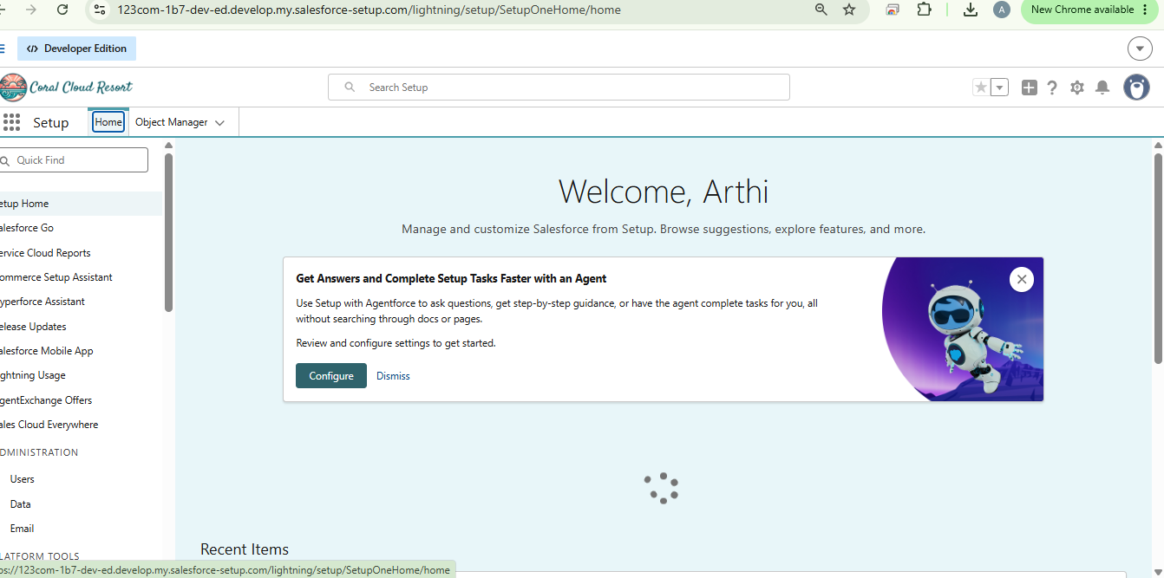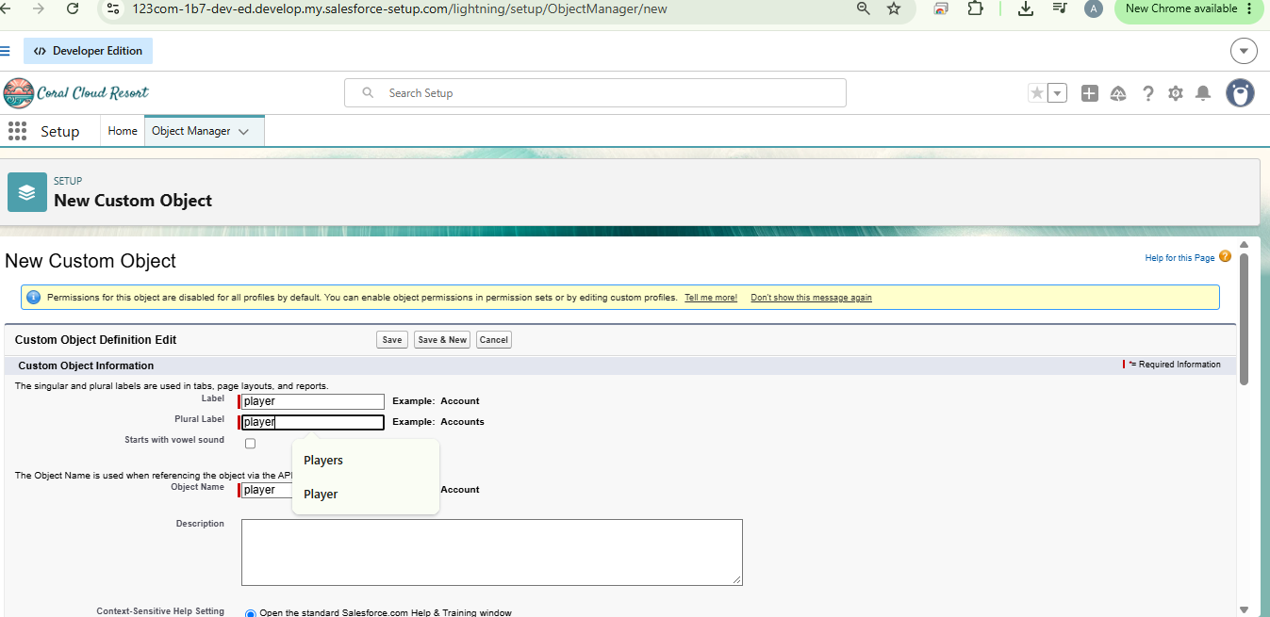

Step 3 – Tab Creation
Tabs are created to provide easy navigation for users within the Salesforce application. Tabs allow users to access objects quickly from the application interface.
Tabs created include:
- Player Tab
- Match Performance Tab
These tabs help users easily view and manage player information and match statistics.
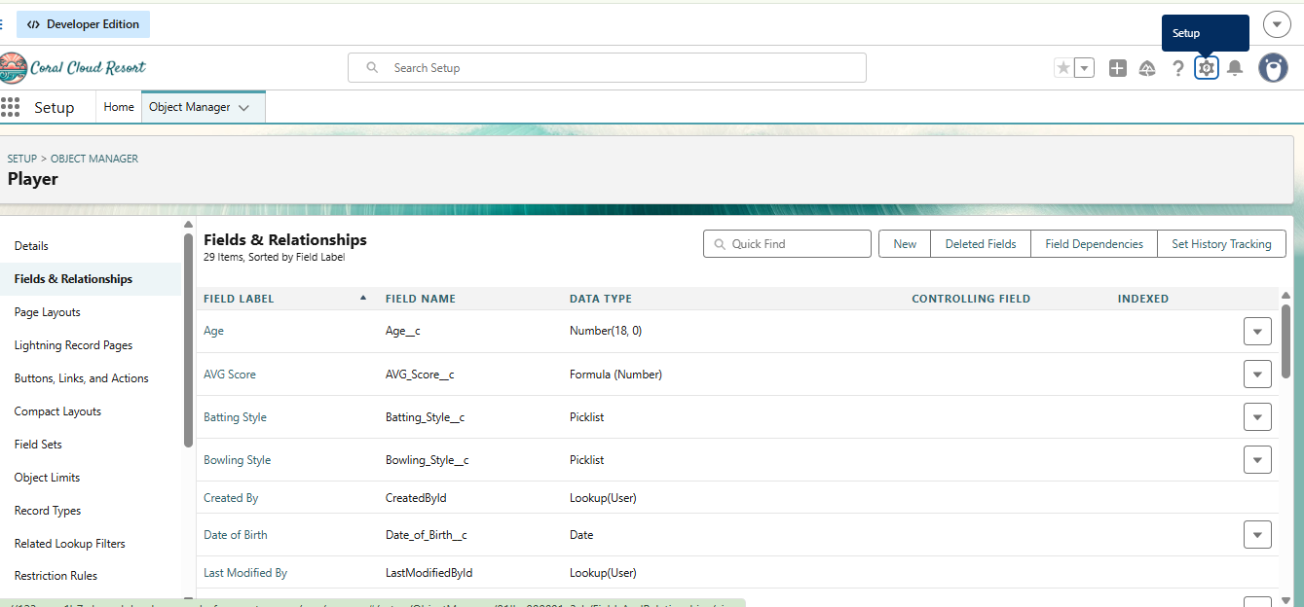

Step 4 – Lightning App Creation
A Lightning application named CRICKSTATS is created to organize all the related objects and tabs.
This application provides a structured interface where users can access different system modules such as player management and match performance tracking.
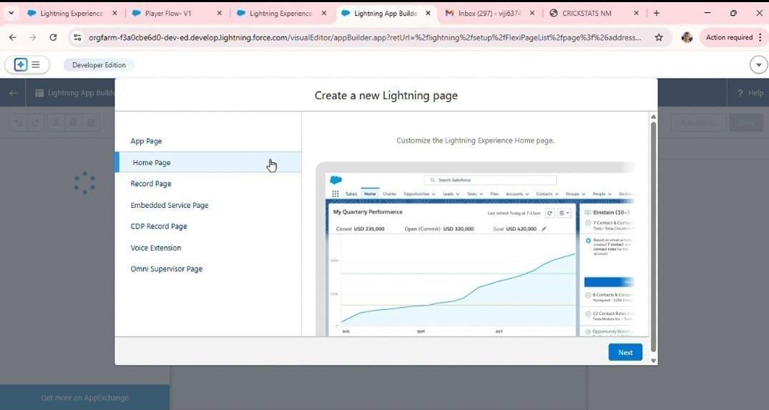
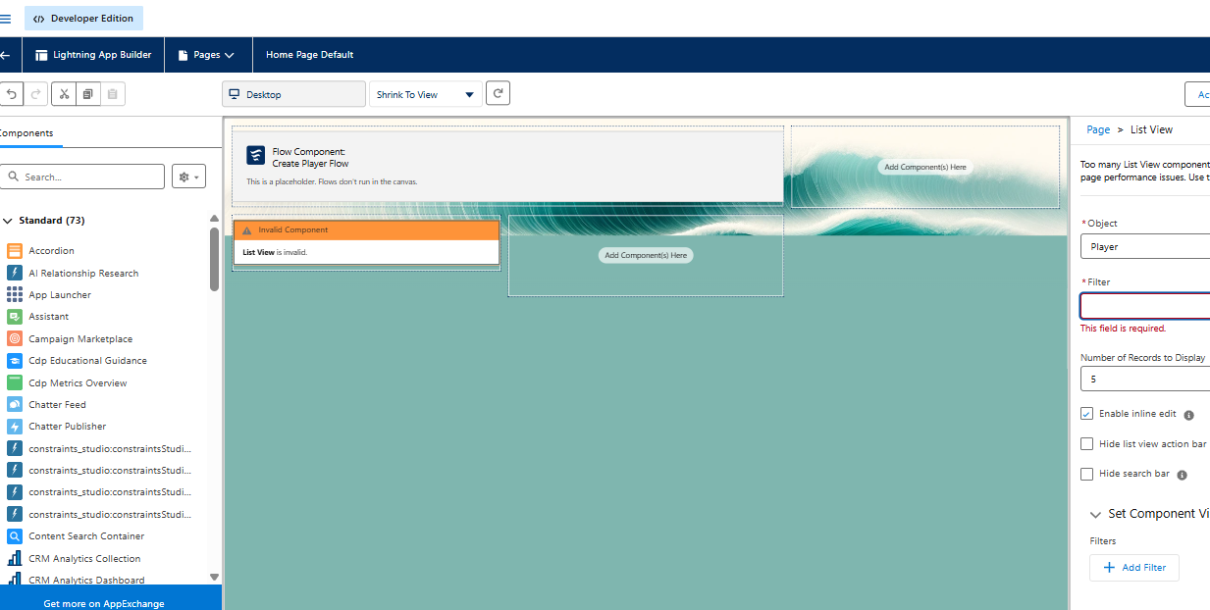

Step 5 – Field Creation
Fields are created inside objects to store specific information. Fields created in the Player Object include:
- Player Name
- Player Number
- Date of Birth
- Role
- Team
These fields help store detailed information about each player.

.., a llghtn1r.g E. X a P ayH FIO'M, IC - lghtnrigE.'> IC - N_. Pl.i)o'@"r X M l,,bl:lr (29T X 0 CRICfjTAT >C G mtur sh11m- X O {h;i,t(iPT + X
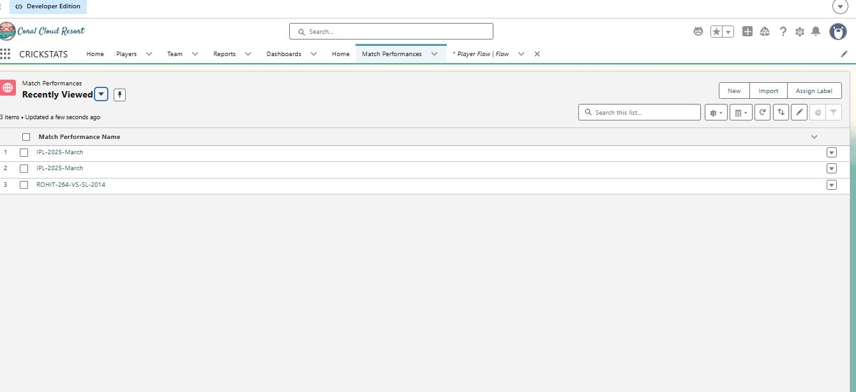

- Ugi,tning E X • Pl.ryet Flov,. X • l9l'ltrl1ng E: X • Nein Player X M .,box 1297] X 0 QOC.i<iTAT )( -$ roh1◻ sh,mr X O CbatG.Pr X +
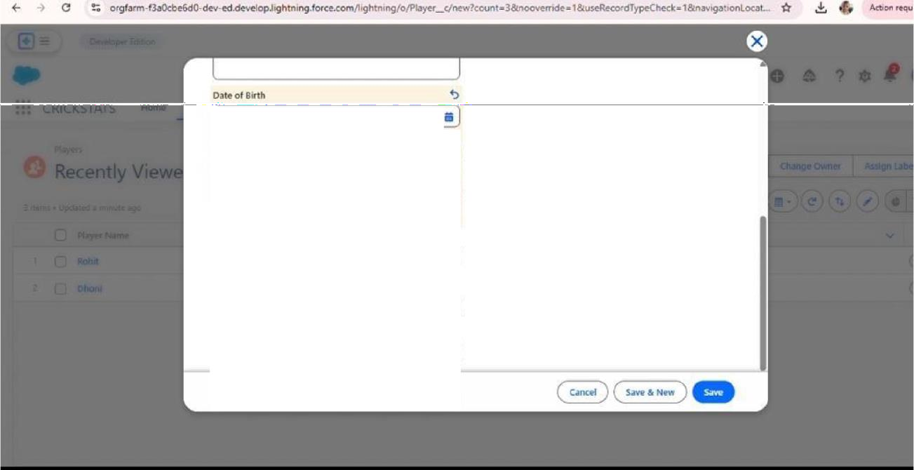

l
Style
( Right- H:indll!d

Style
Niilicnality
l
•l

Step 6 – Object Relationships
Relationships are created between objects to connect player records with their match performance data.
For example:
- Player Object → Match Performance Object
This relationship allows the system to track how each player performs in different matches.
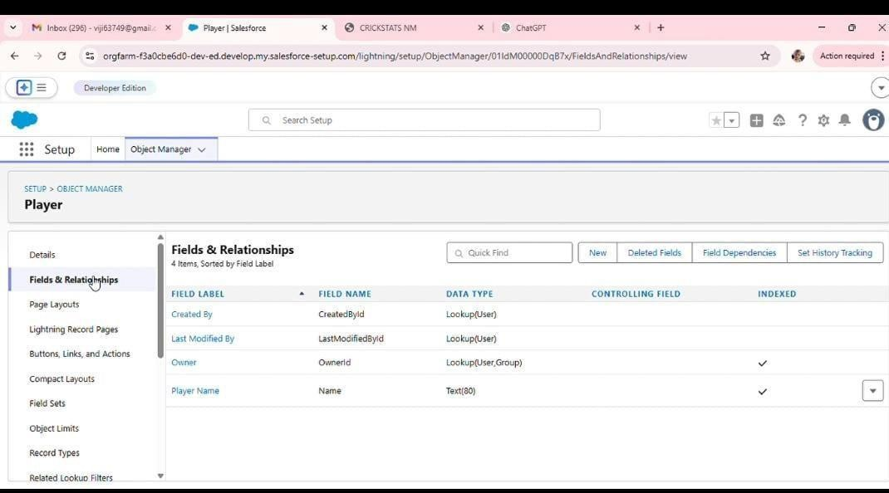

Step 7 – Roll-Up Summary Fields
Roll-up summary fields are used to automatically calculate statistics from related records.
Examples include:
- Total Matches
- Total Runs
- Total Wickets
These fields automatically update whenever new match data is entered.
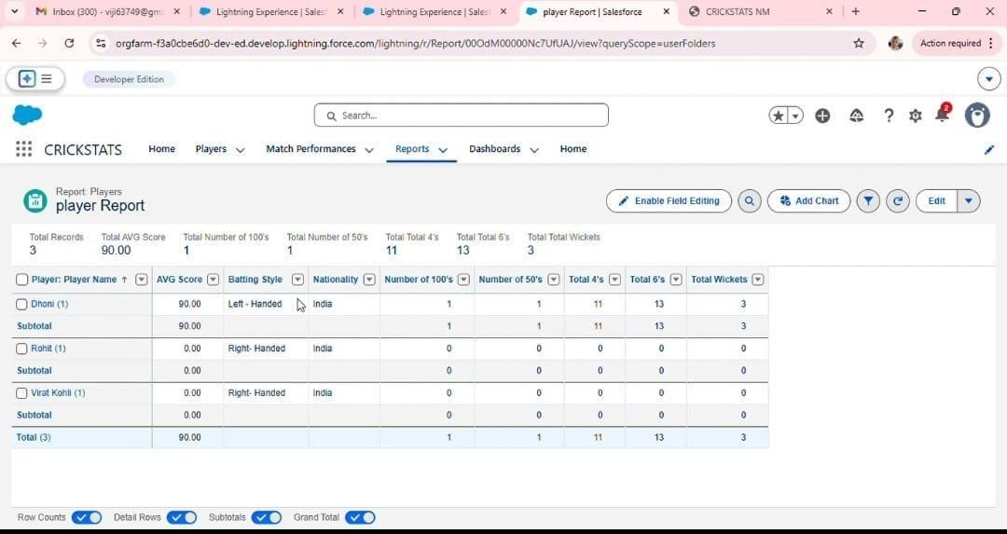

Step 8 – Flow Creation
Salesforce Screen Flow is used to automate processes in the system.
Flows help automate tasks such as:
- Viewing player statistics
- Processing match data
- Generating performance summaries
Automation improves efficiency and reduces manual effort
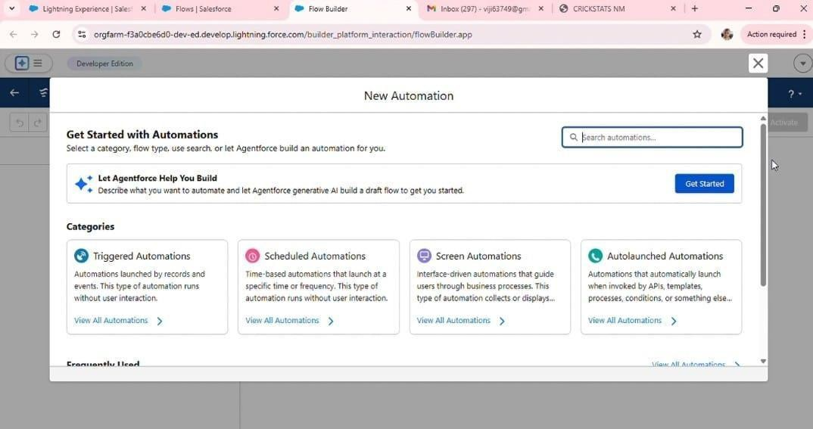
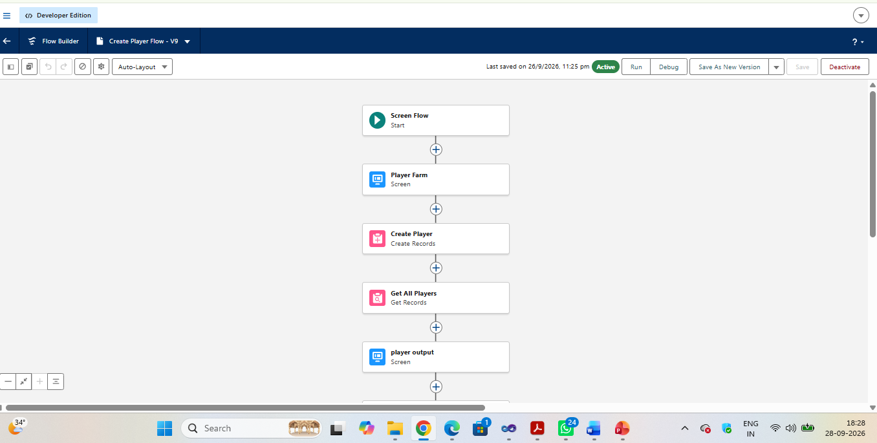

Testing
Testing is an important phase in system development. It ensures that the application works correctly and meets all the requirements.

Testing helps identify errors, bugs, and performance issues before the system is used in real-world situations.
Different testing methods were used for the CRICKSTATS system.

Functional Testing
Functional testing verifies whether all system features work as expected.
Examples include:
- Player registration functionality
- Match data entry
- Report generation
- Dashboard display
This testing ensures that the system performs all required operations correctly.
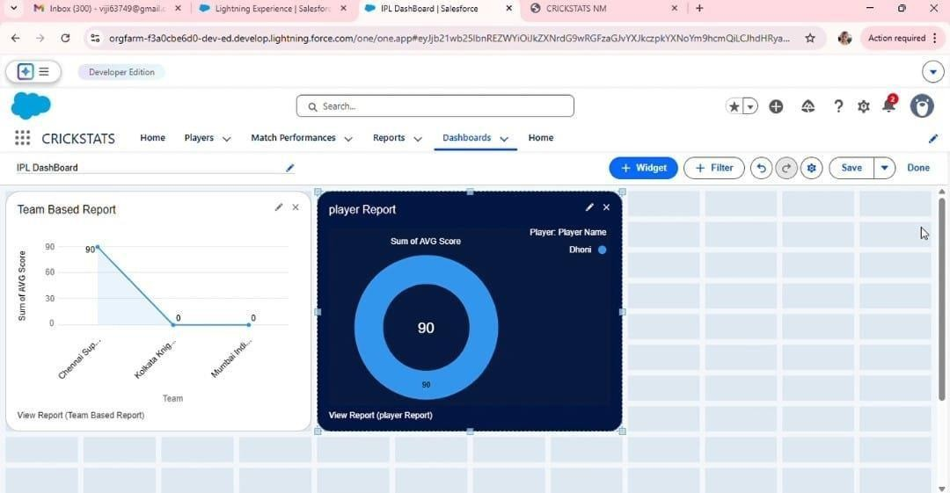

System Testing
System testing evaluates the entire system to ensure that all modules work together properly.
It checks the integration between:
- Player management
- Match performance tracking
- Report generation
System testing ensures that the complete application functions smoothly.

Performance Testing
Performance testing checks whether the system can handle large amounts of data efficiently.
It evaluates:
- System response time
- Data processing speed
- Dashboard loading performance
This ensures that the system remains stable even when handling many records.
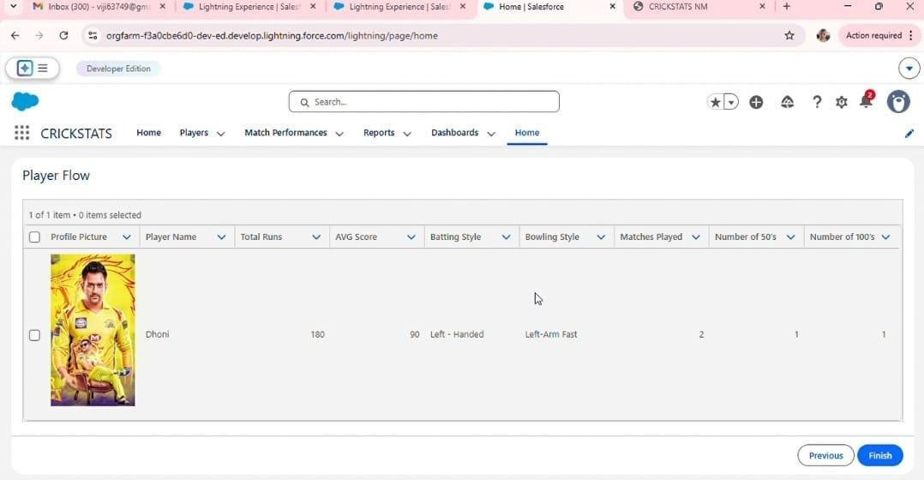

t,,w In.boll: (300) - ll'Jlfi37iG9◻9ir X • llghtrlln!jt Ellpevnce I 5-afec X • l.lghm,n.g b:pBl!nCI!" I Sal◻ IC • HomtiI Salf'Sforce

(- ➔ CJ !. orgf.,rm-Ba:OcbcGdO-dev-ed.di:..,i:[.0p.h9ht111n9.f0rce.coni/1•ghtrung/pogc,'hom◻
•

Hom◻ Playtors v Match PtrlornunceS v Rl!ports v Da.sh003tds v Home
: :: CRICKSTATS
)C 0 oocmAT5 ◻M + 0 X
* 0·
*Q e ◻ ? r:r R (:I
.,

Player Flow
O Promo Pktur@
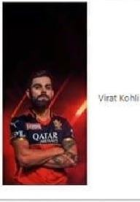
I

v Pl;iyer N◻ | foGIII RUnl | AVG score |  | B.:ittlng Stylct |  | ""'11ng Style | M;ltchM PL1yoo' - NumDIN' of SO'S | Nl.Jmbor of lO<rS V
 |  |  | 0 | Right Ha!Mied |  | Rlght•Ann Spin

D

M lnbn: (300)-Ylji6374!U◻gn ,c • Llg'ltning &perieru:e-J ◻ x - 1.Jghtnrng &pm!!nce I◻◻ ,c - Home I S:11Mforc:e-

f- ➔ C ?; 0rgt.a,rm-f3aOcbe6d0-dEY-ed.cle...efcpJlghtnlng.f0rce.comfhght;r11ng/page/hOme
,c 0 [RICIGT.ATS MM X + 0 X
*

::: CRICKSTATS

Player Flow



Horno P1¥rt v Mald\ Por1or◻ncH v RGports v Duhbo.:itds: v Homo
C:
*0 e ◻ ? r:r _, 8
,I

I of 1 ◻◻Fil • Cl itlffllS w:lected

0 Profile Picwre

D

Pll1;'«Name

_,

To◻ Runs ,,_VGscon saning styio

t:.,
B<>wllngStylo hol.atche:s Played ¥ Numb« 01 S0'5 v Number of 100'.5 v



Results
The results section explains the final output of the system after development and testing. It shows how the CRICKSTATS system works in real-time scenarios and how it successfully tracks and analyses cricket player performance.
After implementing the system on the Salesforce platform, the application was able to manage cricket player statistics efficiently. The system allows users such as coaches and team managers to store player information, record match statistics, and analyse performance through reports and dashboards.
The system successfully performs the following operations:
- Recording cricket player statistics
- Managing player profiles
- Storing match performance data
- Generating performance reports
- Displaying dashboard analytics
These results show that the CRICKSTATS system improves the accuracy and efficiency of cricket performance tracking.

Advantages
The CRICKSTATS system provides several advantages compared to traditional manual record keeping.
- Improves accuracy in tracking player performance
- Provides quick access to player statistics
- Reduces manual calculation errors
- Saves time for coaches and analysts
- Allows easy comparison of player performance
- Provides graphical reports and dashboards for analysis
These advantages help teams make better decisions regarding player selection and performance evaluation.

Limitations
Although the CRICKSTATS system provides many benefits, it also has some limitations.
- The system depends on internet connectivity because it is cloud-based.
- Users must have basic knowledge of the Salesforce platform.
- The system currently focuses only on cricket performance tracking.
- Real-time match data integration is not included in the current version.
These limitations can be addressed in future improvements of the system.

Conclusion
The Cricket Player Performance Tracking System (CRICKSTATS) was developed to manage and analyse cricket player statistics efficiently. The system provides a centralized platform where users can store, manage, and analyse performance data.
By using the Salesforce platform, the system ensures secure data storage, automation, and easy accessibility. The application helps coaches and team managers evaluate player performance using statistical reports and dashboards.
Overall, the CRICKSTATS system simplifies the process of cricket performance tracking and improves decision-making for team management.

Future Scope
The CRICKSTATS system can be further improved by adding advanced features and technologies in the future.
Possible enhancements include:
- AI-based player performance prediction
- Mobile application support
- Real-time match data integration
- Advanced graphical dashboards
- Support for multiple sports such as football or basketball
These improvements will make the system more powerful and useful for sports analytics.

References
The references section includes all the resources used during the development of the project.
Some of the main references include:
- Salesforce Official Documentation
- Salesforce Trailhead Learning Modules
- Naan Mudhalvan Learning Materials
- Online tutorials related to Salesforce development
Providing references helps maintain the credibility of the project and acknowledges the sources used during development.

